A Novel Convolutional Neural Network for Breast Cancer Diagnosis

U. PADMA, CH. RAJESWARI, B. DHARMENDRA, S. SANJAY

U. RAJYALAKSHMI (Project guide)

DEPARTMENT OF ELECTRONICS AND COMMUNICATION ENGINEERING

ADITYA ENGINEERING COLLEGE(A), ADB ROAD , SURAMPALEM

*Abstract* — **Breast cancer is the second leading cause of death across the world in women. Manual diagnosis of breast cancer from histopathological breast images is a costly, time-taking, and non-generalizable process. An alternate method for feature extraction is to learn features from whole slide images directly through a CNN. Training the CNN from scratch requires a large number of labeled images which are sometimes difficult to obtain. The solution is to reuse a pre-trained CNN model as a feature extractor with large image datasets from other fields. In this study, we propose a “Novel CNN” framework based on Transfer Learning for classifying breast cancer histopathology images from the BreakHis dataset. This model is designed to provide fast and accurate diagnostics for breast cancer with binary classification: benign and malignant. In the proposed framework, features from the histopathology images are extracted using a DenseNet-201 pre-trained model. Then the extracted features are fed into the Global average pooling layer, dropout, batch normalization, and dense layers to make a robust hybrid model. The proposed model achieved an accuracy of 99.75%. Such promising results will provide the opportunity to use this model as an automated tool to assist doctors in breast cancer diagnosis and can increase the cancer survival rate.**

Keywords — Convolutional Neural Network, Transfer Learning, Data Augmentation, histopathology images, DenseNet-201.

I. INTRODUCTION

The human body is made up of nearly 37.2 trillion cells. ‘Cancer’ is a disease in which the cells grow abnormally and destroy various parts of the body. The type of cancer is categorized based on the part of the body in which cancer occurs. According to the statistics of the World Health Organization (WHO) in 2020, breast cancer is the most commonly occurring cancer among all types of cancers across the world. There are two distinct types of breast tumors, namely benign (non-cancerous) and malignant (cancerous). Non-cancerous tumors are grown abnormally, but they don’t spread outside of the breast region. These tumors are not life-threatening, but some types of benign breast lumps can increase the chance of getting cancer. The benign tumors can be further divided into 4 sub-classes include adenosis, fibroadenoma, phyllodes tumor, and tabular adenoma. The types of malignant tumors include ductal carcinoma, lobular carcinoma, mucinous carcinoma, and papillary carcinoma. Early detection of breast cancer will reduce the risk of human life and improve the chance of cure by selecting better treatment at the early stages. The general procedure of pathologists to detect breast cancer needs extensive microscopic assessment. Hence, having an automated system like a Computer-Aided Diagnosis (CAD) system is required to make easier the diagnostic process and reduces the complexity of the diagnosis of cancer.

CAD system techniques include the use of fuzzy logic, decision tree, k-means clustering, Artificial Neural Networks, Bayesian networks, diffuse optical tomography, etc. In recent years, Deep Learning methods using Convolutional Neural Networks have been proven to work well in the detection of abnormalities in breast lesions. CNN detects the important features automatically without any human supervision. Compared to conventional methods, CNN reduces the steps involved in the extraction of images. A typical CNN consists of a convolutional layer, a pooling layer, a fully connected layer, and an output layer. There are several types of CNN models such as LeNet, AlexNet, ResNet, GoogleNet, MobileNetV1, ZfNet, DenseNet etc. There are two types of CNN model implementation: Training from scratch and Transfer Learning[1]. Training from scratch requires a large dataset of histopathology images of breast cancer to train the model, which takes time to collect and costs a lot. It also utilizes a lot of computational power and requires more time for training because of its complex architecture. Training the model from the scratch is not required in transfer learning. It saves time and still achieves the required performance. Transfer learning is a deep learning model where a model is trained on one task and reused for another related task. The first step in transfer learning is the model selection and the next step is pruning the model. The final step is training the model. Fine-tuning also can be done as a continuation for the model to improve its performance.

II. LITERATURE SURVEY

The drawbacks of conventional CAD systems help to work on deep learning methods for the early detection of breast cancer. In recent years, CNNs have achieved remarkable advancement in the medical field. For improving generalization and reducing overfitting of the CNN model, a few techniques such as transfer learning, data augmentation, dropout, and batch normalization are appealing solutions[2]. Naresh Khuriwal et al. used a MIAS dataset of 200 images and 12 features for breast cancer detection. Watershed segmentation, color-based segmentation, and adaptive mean filter algorithms are used before training the model and got an accuracy of 98%[3].

He Ma et al. proposed a Fus2Net CNN for the classification of breast ultrasound tumor images. It is evaluated with a dataset of 100 Breast ultrasound tumor images. For making Fus2Net convergence, hyperparameter fine-tuning and also regularization technology is used. The achieved accuracy using Fus2Net is 92%, sensitivity 95.65%, sensitivity 88.89%, and AUC value 0.97 for BUS tumor image classification. The achieved specificity using Fus2Net is 3% lower compared to fine-tuning machine learning model[4]. Qiwen Xu et al. developed a CAD system based on CNN using a diffuse optical tomography system. This architecture contains 5 layers, two convolutional layers, two batch normalization, and one fully connected layer. It obtains 90.2% accuracy, 0.80 specificities, and 0.95 sensitivity for the dataset of a total of 1260 2D grayscale images [5].

Md Zahangir Alom et al. proposed a breast cancer classification method using Inception Recurrent Residual Convolutional Neural Network and it provides a superior classification performance of 2.14% improvement compared to existing machine learning and deep learning-based approaches[6]. For the prediction of breast cancer, deep convolutional neural networks may be used to mimic human decision-making. Alexander et al. implemented a Deep Convolutional Neural Network (DCNN) using a sliding window approach and reached the accuracy of 93% in the breast lesions classification. To get a robust evaluation for DCNN, special care needs to take for balanced data set generation[7].

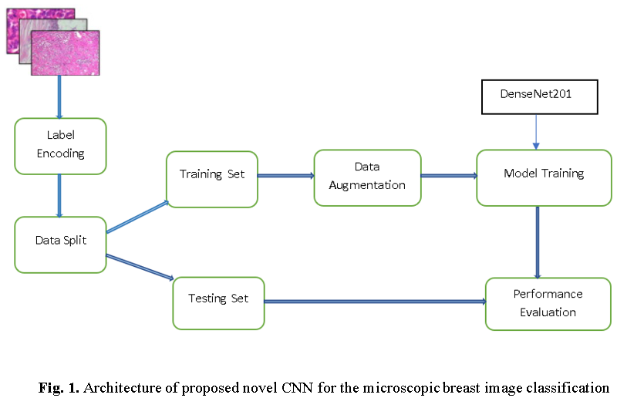Heqing Zhang et al. constructed a CNN model based on InceptionV3, VGG16, VGG19, and ResNet50. The AUCs of used InceptionV3, VGG16, VGG19 and ResNet50 models were 0.905, 0.866, 0.847 and 0.851 respectively. Among all types of CNN models, the InceptionV3 model shows the largest AUC[8]. Ankit Vidyarthi et al. used the architecture of DenseNet-169 with the dense deep architecture of 9 layers. This model achieved an accuracy of 98.21% and an AUC-ROC result of 0.975[9]. Venubabu Rachampudi et al. introduced a classification system of histopathological images using an image data set of RGB-colored images belonging to 8 different classes. It attains the lowest error rate of 22.7% as compared to machine learning methods[10]. The error rate can be further reduced by the modifications of different layer combinations.

Saikat Islam Khan et al. proposed a deep neural network with pre-trained models such as DenseNet-201, VGG16, and NasNetMobile. All the extracted features from the pre-trained models are fed into concatenate layer. This system uses two publicly available datasets of 7909 and 400 microscopic breast tumor images for binary and multi-class classification. For binary classification, it achieved an accuracy of 99% and achieved 98% classification accuracy for multi-class classification[11].

Shuyue Guan et al. discussed three CNN methods for breast cancer diagnosis from mammograms. The three methods are: 1) training a CNN from the scratch or feature extraction model, 2)pre-trained VGG-16 model, and 3) the VGG-16 model with fine-tuning. Combining the pre-trained VGG-16 model with a Neural network(NN) classifier gives the accuracy of about 90.5% for classifying the abnormal and normal cases. In his research, the fine-tuning model classification accuracy is 0.8% higher than the feature extraction method[12]. The present study uses the CNN model based on transfer learning using DenseNet-201 followed by fine-tuning.

III. PROPOSED METHODOLOGY

This section describes the proposed novel CNN for classifying breast cancer histopathology images. Fig. 1. Illustrates the framework of the proposed CNN. The process starts with the extraction of images and converting the labels into a categorical format. Then the data is split into training and testing sets. Data augmentation is done to extensively increase the size of the training dataset. Then the model training is done on the BreakHis dataset. Finally, the proposed model is evaluated using a testing set to measure respective performance metrics.

In this work, we used a publicly available dataset named BreakHis dataset of 7909 samples in which 2440 samples are benign and 5429 samples are malignant. These samples are collected from 82 patients with different magnification factors including ×40, ×100, ×200, and ×400 of two main classes: benign and malignant. Each class has four subclasses; the four types of benign cancer are adenosis (A), fibroadenoma (F), tubular adenoma (TA), and phyllodes tumor (PT). The four subclasses of malignant are ductal carcinoma (DC), lobular carcinoma (LC), mucinous carcinoma (MC), and papillary carcinoma (PC). The proposed CNN model is implemented through the Keras library, which is open-source software. Jupyter notebook IDE and the computer programming language Python are used. Load the necessary libraries like numpy, keras, tensorflow, matplotlib, sklearn, itertools, etc.

After loading the histopathology images from the BreakHis dataset to respective folders, the image samples are resized as per the transfer learning concept. Then, an array of zeros is created for labeling benign images and an array of ones are created for labeling malignant images. The creation of the NumPy array helps to train the model faster by taking less space into memory. The dataset is split into training and testing using the train_test_split() method and applying the to_categorical() method to transform the data before passing it into our CNN model for training. It is used to convert the classes into a set of numbers in proper vector form for compatibility with the models. It is mainly done in classification problems.

The batch size used in our project is 16 and trained our model for 20 epochs. Batch size is the example of the most fundamental hyperparameters to harmonize in deep learning. Larger batch size is used to train the model as it concedes computational speed-ups for the affinity of GPUs. However, it is well comprehended that too high of a batch size will commence to lousy generalization. On the other hand, accepting smaller batch sizes has given faster convergence to great results. The downside of using a smaller batch size is that the model is not guaranteed to converge to the global optima. Therefore, it is often advised that one starts at a small batch size reaping the benefits of faster training dynamics and steadily grows the batch size through training. The data augmentation is also done here. The practice of data augmentation is an effective way to increase the size of our training set. Augmentation of the training examples allows the network to be more diversified, but still representative data points during training. Then a data generator is created to get the data from our created folders into Keras in an automated way. Keras provides convenient python generator functions for this purpose.

The next step is to build our model. As a first feature extractor, DenseNet201 is used as the pre-trained model which is already trained in the ImageNet competition by solving the gradient descent problem. Compared to AlexNet, GoogleNet, and ResNet architectures, the DenseNet-201 pre-trained model will derive more complicated and essential features.

DenseNet-201 is a convolutional neural network that is 201 layers deep. CNN layers are used to learn the features from input data. The chosen learning rate chosen is 0.0001. On top of it, the Global Average Pooling layer is used followed by 50% dropouts. To solve the issue of overfitting, we use two dropout layers. The first dropout layer will exclude 50% of the data and the second dropout layer will exclude 20% of the data during the training of the model. The learned features are reduced by the pooling layer, integrating them into a few important elements. As the CNNs learn quickly, dropout layers are used to slow down the learning process and also help to prevent Neural networks from overfitting.

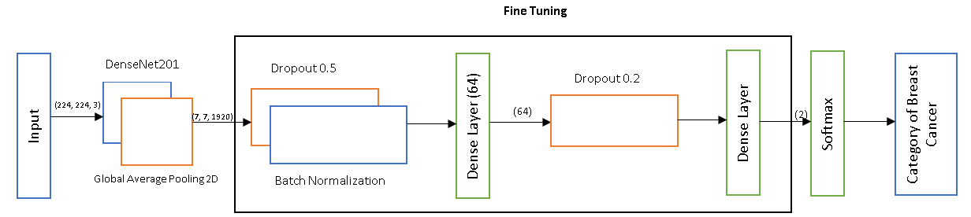The batch Normalization layer is used after completion of CNN layers and pooling, the learned features are flattened by converting the data into a single long feature vector and then passed through a fully connected layer. Each neuron in the previous layer is connected to all neurons in the next layer using a fully connected layer. Several preprocessing steps have been employed before feeding the images into the fine-tuned transfer learning model which is shown in Fig. 2.

**Fig. 2.** Proposed Novel CNN framework

Finally, the output layer is used to make a prediction. Here the Dense block is used to reduce the dimensionality of the feature map. The feature maps indicate the number of times the input is interpreted/processed. The optimizer Adam and the loss function binary-cross-entropy is used. The dense layer is with 2 neurons for the 2 output classes i.e., benign and malignant with SoftMax as the activation function. It is defined using the below expression.

SoftMax(z)i =

Where z is the input vector, exp(zi) and exp(zj) indicate a standard exponential function for input and output vectors respectively. K indicates the number of classes in the classifier. While building the novel CNN, table 1 is extracted.

As the model is for binary classification, the fully connected layer has 2 neurons. The proposed framework performance is evaluated using standard performance metrics namely accuracy, precision, Recall, F1-Score, and AUC. The confusion matrix is generated to know the values of true positive (TP), true negative (TN), false positive (FP), and false negative (FN) of malignant and benign classes. TP is when a case was malignant and predicted malignant, TN is when a case was benign and predicted also benign, FP is when a case was benign and predicted as malignant, and FN is when a case was malignant and predicted as benign.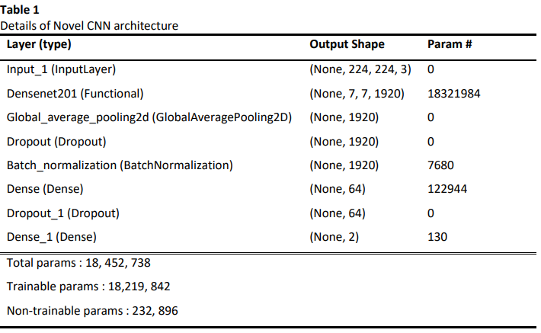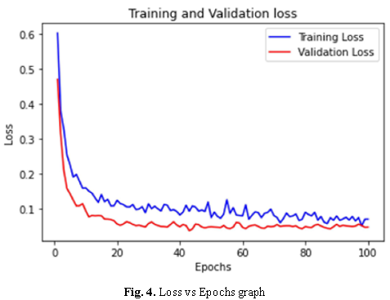

The formulas for the discussed metrics are given below in terms of TN, TP, FN, and FP.

Accuracy =

Recall =

Precision =

F1-Score **=**

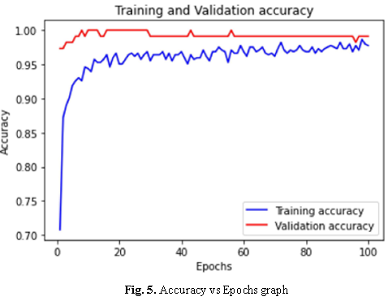IV. RESULTS

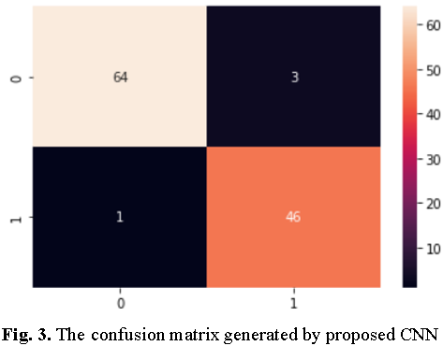To validate the performance of the proposed CNN model, a generated confusion matrix is shown in fig. 3. In the confusion matrix, the x-axis denotes the predicted labels and the y-axis denotes the true labels. As there are only 2 classes, a 2×2 size confusion matrix is generated.

Moreover, the confusion matrix gives results for TP, TN, FP, and FN. These parameters help in the evaluation of accuracy, sensitivity, specificity, and F1-score. The accuracy vs epoch graph and loss vs epoch graph are shown in Fig. 4 and Fig. 5.

The accuracy, precision, recall, F1-Score, ROC-AUC values for proposed model are 0.997, 0.93, 0.97, 0.95 and 0.88 respectively. To compare the performance of the proposed model, a few other methods are also considered. Table 2 represents the comparison of metrics of proposed CNN with considered methods. Fig.6. represents some of the breast histopathological images that are predicted by the designed framework.

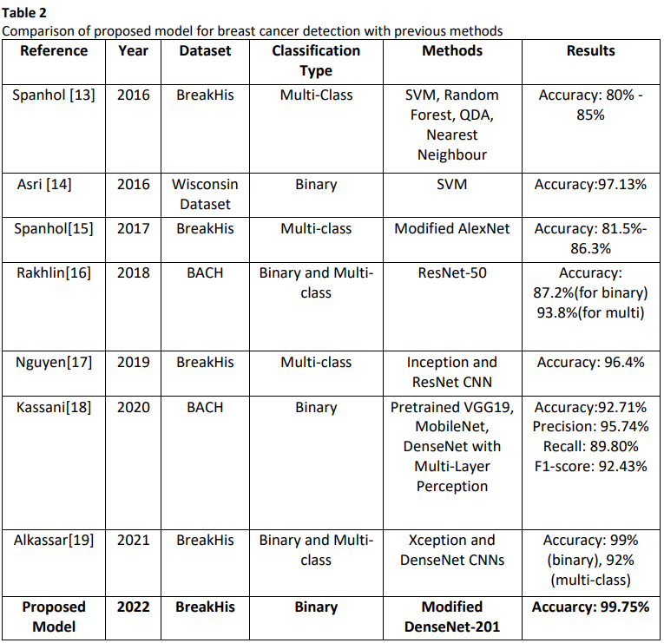

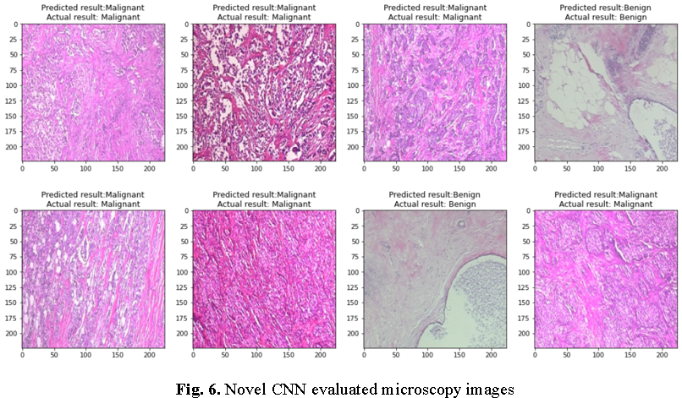

V. CONCLUSION

This paper presents a novel architecture of a Convolutional Neural Network for histopathological image classification. The proposed CNN uses DenseNet-201 as the first feature extractor. It is followed by multiple combinations of global average pooling layer, dropout layer, normalization layer, and dense layer. The experimental analysis of the proposed CNN has been conducted for the BreakHis dataset which is publicly available. The performance has been analyzed in terms of accuracy, precision, recall, F1-Score, AUC, and confusion matrix. For fair analysis, the designed model has been compared with a few other existing methods. From the experimental results, it can be visualized that the proposed novel convolutional neural network provides better accuracy compared to other considered models.

##### References

1. Liew XY, Hameed N, Clos J. A Review of Computer-Aided Expert Systems for Breast Cancer Diagnosis. Cancers (Basel). 2021 Jun 2;13(11):2764. doi: 10.3390/cancers13112764. PMID: 34199444; PMCID: PMC8199592.
2. Abdelhafiz D, Yang C, Ammar R, Nabavi S. Deep convolutional neural networks for mammography: advances, challenges and applications. BMC Bioinformatics. 2019 Jun 6;20(Suppl 11):281. doi: 10.1186/s12859-019-2823-4. PMID: 31167642; PMCID: PMC6551243.
3. N. Khuriwal and N. Mishra, "Breast Cancer Detection From Histopathological Images Using Deep Learning," 2018 3rd International Conference and Workshops on Recent Advances and Innovations in Engineering (ICRAIE), 2018.
4. Ma, H., Tian, R., Li, H. et al. Fus2Net: a novel Convolutional Neural Network for classification of benign and malignant breast tumor in ultrasound images. BioMed Eng OnLine 20, 112 (2021).
5. Radouane Karli, Hassan Ammor “Rectangular Patch Antenna for Dual-Band RFID and WLAN Applications” Springer, Electronic and Communication Laboratory, Science Business Media New York 2015.
6. Xu, Q., Wang, X. & Jiang, H. Convolutional neural network for breast cancer diagnosis using diffuse optical tomography. Vis. Comput. Ind. Biomed. Art 2, 1 (2019).
7. Ciritsis, A., Rossi, C., Eberhard, M. et al. Automatic classification of ultrasound breast lesions using a deep convolutional neural network mimicking human decision-making. Eur Radiol 29, 5458–5468 (2019).
8. Zhang, H., Han, L., Chen, K. et al. Diagnostic Efficiency of the Breast Ultrasound Computer-Aided Prediction Model Based on Convolutional Neural Network in Breast Cancer. J Digit Imaging 33, 1218–1223 (2020).
9. Vidyarthi, A., Patel, A. Deep assisted dense model based classification of invasive ductal breast histology images. Neural Comput & Applic 33, 12989–12999 (2021).
10. Rachapudi, V., Lavanya Devi, G. Improved convolutional neural network based histopathological image classification. Evol. Intel. 14, 1337–1343 (2021).
11. Saikat Islam Khan, Ashef Shahrior, Razaul Karim, Mahmodul Hasan, Anichur Rahman, MultiNet: A deep neural network approach for detecting breast cancer through multi-scale feature fusion, Journal of King Saud University - Computer and Information Sciences, 2021.
12. S. Guan and M. Loew, "Breast Cancer Detection Using Transfer Learning in Convolutional Neural Networks," 2017 IEEE Applied Imagery Pattern Recognition Workshop (AIPR), 2017.
13. Spanhol FA, Oliveira LS, Petitjean C, Heutte L (2016) A dataset for breast cancer histopathological image classifcation. IEEE Trans Biomed Eng 63(7):1455–1462.
14. Asri, H.; Mousannif, H.; Al Moatassime, H.; Noel, T. Using Machine Learning Algorithms for Breast Cancer Risk Prediction and Diagnosis. Procedia Comput. Sci. 2016, 83, 1064–1069.
15. Rakhlin, A.; Shvets, A.; Iglovikov, V.; Kalinin, A.A. Deep Convolutional Neural Networks for Breast Cancer Histology Image Analysis. In Proceedings of the 15th International Conference, ICIAR 2018.
16. F. A. Spanhol, L. S. Oliveira, P. R. Cavalin, C. Petitjean and L. Heutte, "Deep features for breast cancer histopathological image classification," 2017 IEEE International Conference on Systems, Man, and Cybernetics (SMC), 2017, pp. 1868-1873.
17. Vo DM, Nguyen N-Q, Lee S-W (2019) Classification of breast cancer histology images using incremental boosting convolution networks. Inf Sci 482:123–138.
18. kassani, S.H.; Kassani, P.H.; Wesolowski, M.J.; Schneider, K.A.; Deters, R. Classification of Histopathological Biopsy Images Using Ensemble of Deep Learning Networks. arXiv 2019, arXiv:1909.11870.
19. Alkassar, S.; Jebur, B.A.; Abdullah, M.A.M.; Al-Khalidy, J.H.; Chambers, J.A. Going Deeper: Magnification-Invariant Approach for Breast Cancer Classification Using Histopathological Images. IET Comput. Vis. 2021, 15, 151–164. [CrossRef]